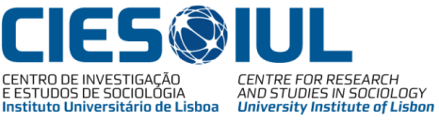
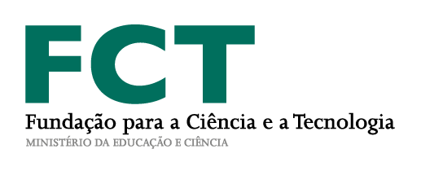

“Two decades discourse about globalizing social sciences – concepts, strategies, achievements”

International Conference
for Europe

26-28 April 2018, room C205, Building 2

Lisbon, Portugal
Instituto Universitário de Lisboa
https://www.iscte-iul.pt/campus

Supported by the

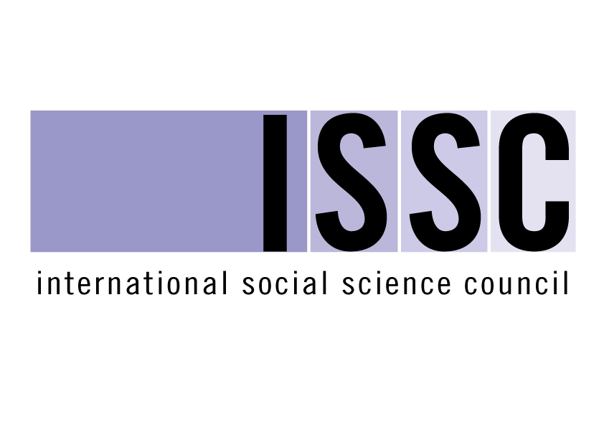

Day 1, 26. April

09.30 – 10.00 Registration and Coffee

10.00 – 10:30 Welcome talks
Helena Carreiras , Escola de Sociologia e Políticas Públicas
João Sebastião, Centro de Investigação e Estudos de Sociologia
Michael Kuhn, World Social Sciences and Humanities Network
António Pedro Dores, Organization committee

10.30 – 12.30
Chair: Pierre Guibentif

10.30 – 11.30 Social Knowledge about the Modern Society in the Conditions of Globalization Nataly Kuleshova, Lomonosov Moscow State University

11.30 – 12.30 Methodological Glocalism: The Social Science Of The Global And The Globalization Of Social Science, Roland Robertson, University of Pittsburgh, USA and University of Aberdeen, UK

12.30 – 14.00 Lunch break

14.00 – 16.00
Chair: António Pedro Dores

14.00 – 15.00 Urban Ethnography, an Interdisciplinary Field of Knowledge? Rita Cachado, CIES-IUL

15.00 – 16.00 Globalization Of Social Sciences, Mobility, Precarity And Diversity, Vinicius Kauê Ferreira , Ecole des Hautes Etudes en Sciences Sociales – Paris

16.00 – 16.30 Coffee break

16.30 – 18.30
Chair: Andrea Borghini

16.30 – 17.30 Sociological Strategies of the 1990/2010 Developed in the Face of Globalization and Sustainable Development: Interdependence, State and Subjects, Gilles Verpraet, Sofiapol University Paris Ouest Nanterre

17.30 – 18.30
From cultural relativism to critical pluralism. How globalization changes the ideas of universality, diversity and multiculturalism, Enzo Colombo, University of Milan and Gianmarco Navarini - University of Milano-Bicocca

End day 1

Day 2, 27. April

09.30 – 13.00

Chair: Roland Robertson

09.30 - 10.30 Two Ways of Creating Globalising Social Sciences – Universalization of Universalism and Relativization of Relativism, Shujiro Yazawa, Seijo University

10.30 – 11.30 Secularization as a Concept of Global Social Thought: Genealogical Analysis of its Pre-Sociological Proveniences and of its Emergence in Nineteenth-Century Sociology, Jorge Botelho Moniz, Universidade Nova de Lisboa

11.30 – 12.00 Coffee break

12.00 – 13.00 Is There Something One Can Call Society? António Pedro Dores, ISCTE-Instituto Universitário de Lisboa

13.00 – 14.30 Lunch break

14.30 – 16.30
Chair: Alla Stremovskaya

14.30 – 15.30 Academic Culture: a Missing Analytical Aspect to Understand the Globalizing Academic Work, Kazumi Okamoto, World SSH Net

15.30 – 16.30 Globalization and the Loss of Identity: Political Science at the Crossroad, Omitola Bolaji and Akirinde Olawale Olufemi, Osun State University

16.30 – 17.00 Coffee break

17.00 – 18.00

Chair: Michael Kuhn

Overall discussion with special guest Chris Caswill as discussant of the main issues raised by the conference

End day 2

Day 3, 28. April

09.00 – 11.00
Chair: Enzo Colombo

09.00 – 10.00 Researching On International Education: Overcoming The Paradigm Of Methodological Nationalism? Anne Schippling, CIES-IUL, Martin-Luther-Universität Halle-Wittenberg, Fern Universität in Hagen

10.00 – 11.00 Public Sociology and Global World Perspective: a Critical View, Andrea Borghini, University of Pisa

11.00 – 11.30 Coffee break

11.30 – 13.30
Chair: Anne Schippling

11.30 – 12.30 How Foreign Policy Studies Were Never Globalized: Foreign Policy Analysis, Political Globalization, and Multi-Level Governance, Pedro Ponte e Sousa, FCSH-UNL, IPRI

12.30 – 13.30 Spatial knowledge - The ultimate elimination of objectivity from social science theorizing, Michael Kuhn, World SSH Net

13.30 – 15.00 Lunch break

15.00 – 17.00
Chair: Michael Kuhn

Overall discussions of the main issues raised by the conference

